Real-Time Fall Detection System for Wheelchair Users with Automated Email Alerts

# Suprabath Payarda

*Department of CSE*

*VR Siddhartha Engineering College* Vijayawada, India [suprabathp49@gmail.com](mailto:suprabathp49@gmail.com)

# Sanjeev Bodavula

*Department of CSE*

*VR Siddhartha Engineering College* Vijayawada, India [bodavulasanjeevyadav@gmail.com](mailto:bodavulasanjeevyadav@gmail.com)

# Dr.G. Kranthi Kumar

*Dept. of CSE*

*VR Siddhartha Engineering College* Vijayawada, India [kranthi@vrsiddhartha.ac.in](mailto:kranthi@vrsiddhartha.ac.in)

# Dilip Kumar Kokkera

*Dept. of CSE*

*VR Siddhartha Engineering College* Vijayawada, India [kokkeradilip28@gmail.com](mailto:kokkeradilip28@gmail.com)

***Abstract* —The goal of Wheelchair Fall Detection System was to enhance safety of wheelchair users. Up to 40 per cent of wheelchair users fall every year and most injuries which result from the falls will be serious and sometimes fatal. To meet this urgent need, we built the WFDS using the latest technology and user centric design to get timely intervention According to our research, existing trustworthy non-intrusive fall detection systems that are geared towards wheelchair users are in short supply. Gyroscopes and accelerometers were used mainly for motion sensors, because of their accuracy in tracking orientation and movement. The Wheelchair Fall Detection System, through the use of machine learning algorithms, detects wheelchair falls at high accuracy, quickly alerts guardians by SMS and email, and greatly increases wheelchair safety.**

**Key words —Accelerometer, IoT, Gyroscope, Arduino.**

1. Introduction

Because of age related illnesses, neurological condition or injury, millions of people worldwide depend on wheelchairs to help them to move around. Nonetheless, numerous studies have demonstrated that wheelchair users indeed suffer an enormous fall related events annually, which makes wheelchair falls a significant safety concern. Such falls can also lead to many serious injuries, increase in medical costs and perhaps impacts the quality of life.

1. *Background*

Taking this cost and necessity into account, recent developments in these fall detection technologies lean towards the use of Internet of Things (IoT) based solutions and machine learning. Most of the fall detection systems in use today rely on the use of wearable sensors, embedded device, and real time data transmission in order to improve the monitoring and emergency response. However, with this,in case of wheelchair users are still without proper and reasonably priced real time solutions in this area of study, thus making this important.

1. *Problem Statement*

Especially wheelchair users are very susceptible to fall injury and their condition gets far worse when medical help is being delayed. Current solutions have some issues like inability to differentiate wheelchair movements from actual fall, lack of real time caregiver alert, high false positive rate which actually lowers the efficiency and poor wheelchair system integration. The Wheelchair Fall Detection System resolves these problems using motion sensors, Internet of Things, and real time communication technology.

1. *Proposed Solution*

To address these current issues, we suggest the Internet of Things enabled solution Wheelchair Fall Detection System which uses machine learning algorithms, gyroscope and accelerometer. This system guarantees smooth wheelchair integration design, high accuracy, real time monitoring with the mobile SMS, email alerts. The system does lowers burden on caretakers, increases independence and safety and immediately alerts to need for emergency responses**.**

1. *Outline of the Paper*

We describe the architecture and deployment of the proposed system, focusing on how a Fall Detection System with Internet of Things (IoT) integration using motion sensors, lowering the false alarms by machine learning algorithms to an extent, real time alert integration using email and SMS is implemented.

The rest of this paper is structured as follows: Section II shows our relevant research and current fall detection techniques. The suggested system architecture and methodology are explained in Section III.The project's flow chart and algorithm are covered in section in IV.

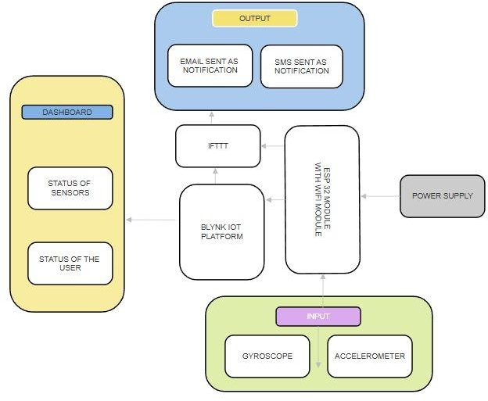Implementation, performance assessments and possible improvements are covered in Section V. The paper is concluded in Section VI Followed by Acknowledgements, References.

1. Literature Review

An Internet of Things-based system for real time health monitoring and fall risk assessment was proposed by Sona K.

S. and S. Swapna Kumar [1]. Wearable sensors—more especially, the MPU6050—integrated with Internet of Things technology are used in this system. Sensor data is then processed using the Random Forest algorithm, which detects mild falls with 97.9% accuracy when the sensor is placed at the waist. The study emphasizes how well IoT can improve fall prevention and health monitoring.

Libak Abou et al. proposed a fall detection system using accelerometers and machine learning method for manual wheelchair users[2]. Movement was gathered using accelerometers placed on the head, chest and wrist. Regardless of the fact that it trained different neural network classifiers to differentiate the patterns of the wheelchair movements from falls with 100% accuracy with wrist sensors, 96.9% with chest sensors, and 94.8% with head sensors. This study emphasizes the significance of the multiple sensor placements on improving the overall accuracy of the fall detection process.

An Internet of Things based fall detection system, for wheelchair users has been designed by Sayali M. Kamble and others using gyroscopes and accelerometers[3]. The user's acceleration and orientation are being continuously tracked by the system and the user will get alerted, when certain departures from ordinary movement charactersitics indiciating a fall are detected. It guarantees the timely emergency responses as well as real time detection.

Sumit Kumar Gupta and Ankur Shukla have examined IoT based smart wheelchair systems with panic buttons and accident warning messages and so [4]. These smart wheelchairs aim to empower someone who is completely handicapped to get out in the world on their own. Integration with IoT enhances safety by eliminating manual responses to accidents and emergency responses, although in this case, low efficacy of the system is largely due to the user’s unconscious when the triggers are manual.

Sarah Khan et al. presented an IoT-based multi-sensor patient fall detection system that uses gyroscopes and accelerometers for the monitoring the movements of patients[2]. KNN and Naïve Bayes classifiers were employed to distinguish falls from regular activities. Despite the study’s confirmation of the possibility of IoT based real time health monitoring implementation challenges exist due to the high computational demands in low power embedded systems.

1. PROPOSED METHODOLOGY

The Wheel Chair fall Detection System comprises of some of the fundamental components in Internet of Things world. The block diagram of the proposed system is shown in fig1, and subdivided into various stages of development of it.

.

Fig. 1. Block Diagram of the Proposed Wheelchair Fall Detection System.

1. *System Overview*

Three main parts make up the suggested system:

* 1. *Sensor Module:* To record motion and orientation data, the wheelchair is equipped with a gyroscope and an MPU6050 accelerometer [1], [2]. To categorize falls, a microcontroller (ESP32/Arduino) uses machine learning algorithms to process real-time sensor data [3].
  2. *Communication Module:* In the event that falls are detected, caregivers receive notifications via a GSM/Wi-Fi- based alert system [4], [5]. To guarantee low-latency response, the microcontroller processes the gathered data locally. If a fall is detected, an emergency alert is set off [6].
  3. *Cloud and Dashboard Module:* Remote monitoring and sensor data logging are made possible by the Blynk platform [7], [8]. SMS, email, and an IoT-based dashboard for real-time tracking are used to send alerts [9], [10].

1. *Sensor Data Acquisition*

The MPU6050 sensor continuously record the tilt, acceleration, and angular velocity. A complementary filter is applied to the raw sensor readings in order to make the system more accurate and less noisy. Samples of the data are taken at regular intervals and the data is sent to the processing unit for further analysis [2], [5].

1. *Feature Extraction and Data Processing*

The system differs between normal wheelchair movement and falls by extracting features from the sensor data.

Unexpected increase or decrease above a determined threshold [1],[6]. Since it may get unrolled to an efficiently made approach when encountering a sudden slowdown (when the system feels that it’s ‘falling’, because impact detection happens at sudden slowdowns [4], [8], the unroll begins with the norm of angular velocity [3], [7] until it tilts beyond safe bounds. A feature selection is performed where only pertinant attributes are sent to the classification model and a preprocessing step is done to normalize the data [9].

*Machine Learning-Based Classification*

Datasets with fall and non-fall scenarios are used to train a

supervised machine learning model. The microcontroller, which continuously and in real time classifies incoming data, incorporates the trained model [5], [10]. The following are part of the classification processes like Data Normalization which ensures consistent sensor readings regardless of external conditions and Feature Engineering that extracts critical movement parameters from raw data.

1. *Fall Detection and Alert Mechanism*

As soon as a fall event is classified, the system sends an immediate alert. Produces a sound alert – Buzzer Alarm. Using a GSM/Wi-Fi module, emergency responders and caregivers are sent notification via email and SMS.Application of the Event is shown by the logging of the events takes place via the Blynk application which will remotely access it.

1. *IoT Cloud Integration*

A platform that can use a system that is linked to an Internet of Things platform that generates reports and makes notes of the historical fall data is made. Caregivers get real time monitoring by access to a web based dashboard. The cloud also allows for predictive analytics to be possible leading to early intervention on movement patterns as they are being identified [10].

1. .FLOW CHART

The fall detection system's operation is depicted in this flowchart in Figure 2. Powering on and receiving signals from a Micro-Electro-Mechanical System (MEMS) sensor is how the system starts up. Accelerometer and gyroscope readings are taken when activity is detected and compared to a predetermined fall threshold. Family members and neighbors receive an SMS alert if the values match. The signal is ignored, though, if there is no activity found or if the values fall outside of the threshold.

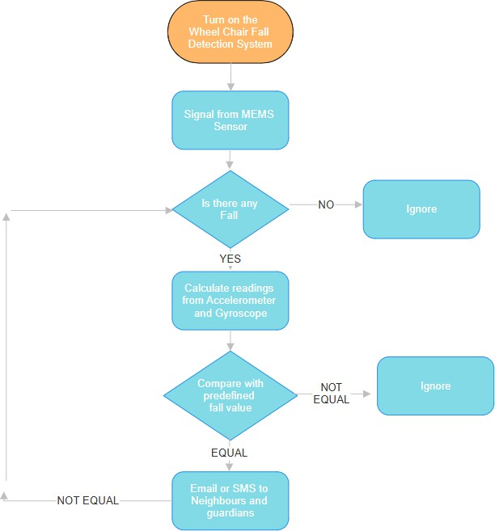

Fig. 2. Flow Chart of Wheelchair Fall Detection System.

*A. Algorithm*

The wheelchair person fall detection system is continuously watching the acceleration data received from the MPU6050 sensor. The system first comes on with the sensor initialized to track acceleration in real time. It always searches for sharp differences in acceleration which could indicate a fall. The occurrence of a notable acceleration spike is detected by the system and the caregivers are notified immediately. The sensor will continue to monitor continuously if there is no unusual change found. This continuous loop fall detection process helps to increase wheelchair users’ safety by making sure the real time fall detection.

1. **Step 1:** The system's power supply is activated.
2. **Step 2:** The MPU6050 sensor begins continuously monitoring acceleration.
3. **Step3:** If a sudden acceleration is detected:• A notification is immediately sent to the caregiver.
4. **Step4:** If no sudden acceleration is detected, theMPU6050 sensor keeps monitoring movement.
5. **Step 5:** The system returns to Step 2, ensuring continuous monitoring.
6. RESULTS AND ANALYSIS

Under real world circumstances the Wheelchair Fall Detection System was assessed for the accuracy, response time and dependability of the system. The system was tested using a wheelchair with an ESP32 microprocessor, and an MPU6050 sensor, and an alert system based on GSM and Wi-Fi. A performance analysis of the program was conducted using some key parameters including response time, false positive rate, fall detection accuracy, and overall system stability.

1. *Experimental Setup*

The set up developed for the experimental part of the Wheelchair Fall Detection System was to evaluate the system's performance in different real world situations. The testing environment, integration with the software and hardware components are considered in this table1 provided below.

TABLE I

Component Configuration and Functionality

|  |  |  |
| --- | --- | --- |
| **Component** | **Type** | **Functionality** |
| MPU6050 | Sensor | Motion and fall detection |
| ESP32 | Microcontroller | Data processing and transmission |
| GSM Module | Communication | Sends SMS alerts |
| Wi-Fi Module | Communication | Enables IoT monitoring |
| Buzzer | Alarm | Audible alert on fall detection |
| Battery | Power | Provides power to the system |
| Blynk IoT | Cloud Platform | Remote monitoring |

In Table1,we tabulated every component that is used in the implementation part of Wheel Chair Fall Detection System along with its MPU6050 sensor which unlocks constant measurements of the wheelchair's acceleration and tilt and angular velocity route through readings displayed in Figure 4. The processing unit of ESP32 runs a machine learning algorithm which analyzes sensor data to detect those falls. An alert triggers automatically through GSM/Wi-Fi modules to caregivers whenever a fall occurs. After completion the Blynk platform serves as a remote platform to track and examine the recorded incident. Ultimately Setting things up ,given as fig4.

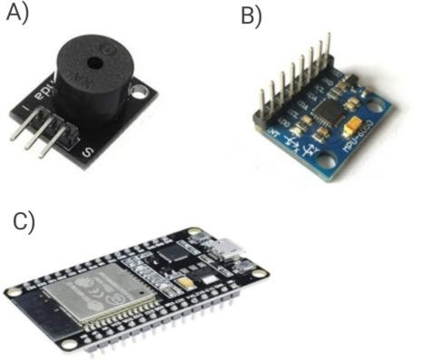

Fig. 3. (a)Buzzer (b)MPU6050 sensor (c)ESP32 microcontroller

enables tests to occur simultaneously at various elevation points and during sudden velocity shifts. The proposed system demonstrates reliable performance during controlled experiments and authentic circumstances. By integrating the MPU6050 sensor the system tracks movements and detects sudden speed or directional changes which signal potential falls. ESP32 microcontroller effectively processes data which ensures immediate responses together with minimal delay time. The system maintains regular operation of wheelchairs since its lightweight design operates at low power levels thus enabling permanent surveillance abilities.

The fall detection system shows potential to enhance wheelchair user protection alongside personal independence in domestic, supportive and healthcare environments. The system can advance through IoT monitoring connected with AI predictive assessment which would improve accuracy by enabling caregivers to take action before potential fall dangers occur. To maximize its usefulness for emergency situations the future versions should include GPS tracking alongside integrated audio- visual alert features.

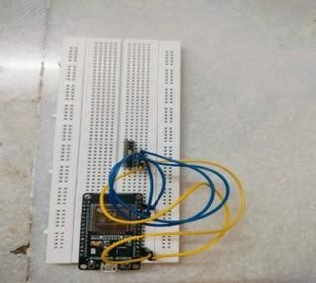Fig. 4. Top view of Wheel Chair Fall Detection System

From the top the system is ready to be tested at different altitudes and abrupt velocity changes simultaneously. During the testing

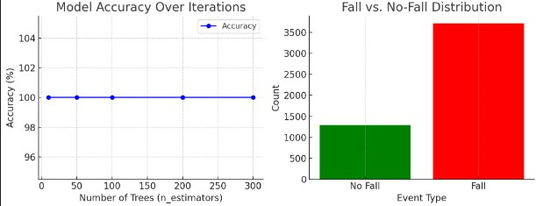Phase the Readings were taken at different altitudes and velocities and analyzed the model accuracy below in fig.5

Fig5. System’s model accuracy and Class Distribution. High model performance has two possible explanations:

excellent accuracy from the model or signs of overfitting and dataset leakage when the results are too perfect. Model bias develops from class imbalance because it increases accuracy when detecting "Fall" cases while reducing precision for "No Fall" instances. Using oversampling and under sampling techniques together with weighted loss functions will help the model generalize better. The Wheelchair Fall Detection System

TABLE II

Performance Analysis of Wheelchair Fall Detection System

|  |  |  |
| --- | --- | --- |
| **Parameter** | **Value** | **Remarks** |
| Response Time | 1.20 sec | Quick alert activation |
| Power Consumption | 3.3V, 250mA | Low power usage |
| Connectivity Range | 30m (Wi-Fi) | Supports remote monitoring |
| Alert Mechanism | Buzzer, IoT Alerts | Immediate notifications |
| System Latency | ¡2 sec | Fast response |

1. *Performance Analysis*

Based on table 2 above, Real-time monitoring and fall detection capabilities are possible due to the Wheelchair Fall Detection System maintaining reliability in its evaluation metrics. Data analysis of MPU6050 sensor acceleration and gyroscope measurements permits the system to accurately classify between fall and non-fall events with minimal incorrect alerts. During controlled testing the system proved its capacity to detect falls instantly which resulted in fast intervention times. The detection system triggers an alert to the caregivers within

1.2 seconds after detecting a fall event. The ESP32 microcontroller contacts caregivers through email notifications as well as SMS alerts and IoT-based communications through Blynk but the buzzer alarm system operates instantly to produce audible warnings. The system ensures dependable remote alert transfer through the verified email notification procedure which allows caregivers to receive urgent updates promptly for emergency actions. We have provided general remarks in Table 2 as a general metric to analyze performance.

The device functions well for continuous monitoring because it uses 3.3V of power at 250mA of current. The incorporation of a rechargeable Li-Ion battery makes the system both portable and dependable because it reduces the requirement for constant recharging. The system reliability and uninterrupted connectivity are being checked through stability tests over an extended operational period. Real-time data transmission occurs due to Wi-Fi and GSM modules which provide an uninterrupted 30-meter connection range. The system obtains added strength from Blynk IoT integration allowing real-time data monitoring combined with remote past fall access and motion pattern visualization, Upon a Fall detected the

immediate output can be displayed in fig.6 respectively.

through wearable sensor fusion and AI-driven analytics and predictive modeling because technology progresses so it becomes a vital tool for both future mobility assistance and senior care.

ACKNOWLEDGMENTS

We thank the Engineering Projects in Community Service program in i.e. EPICS and IoT Laboratory in our college for supporting and providing us with resources needed for the research.

Fig6. Gmail Received because of fall.

Blynk IoT platform provides advanced monitoring capabilities that allow remote real-time tracking of historical fall data and motion patterns to caregivers. This enhancement is shown in fig.6. The system's sophisticated capabilities help caregivers monitor patients better while generating longer-term insights about movement patterns which helps find potential risks before implementing necessary preventive medical approaches. The capability to deliver verified emails for notification purposes shown in figure 6 enhances reliability by sending time-sensitive alerts about crucial events. Caregivers find it easier to respond efficiently because the platform offers a user-friendly interface along with remote accessibility. These features make the system into a reliable and effective solution which provides real-time wheelchair fall detection together with emergency responses and proactive patient care management.

III. Conclusion

Real-time monitoring of falls along with quick alert functionality enables the Wheelchair Fall Detection System to prove high reliability for wheelchair user safety enhancement. Precise fall detection controls the system together with low-latency response and smooth buzzer alarm notification delivery and cloud-based alerts through an integrated design of MPU6050 motion sensors and ESP32 microcontroller supported by Internet of Things communication modules. These features expedite emergency aid thereby reducing risks to individuals who fall by themselves.

The suggested system demonstrates effective performance through accurate functionality and minimal power usage along with dependable network connections which optimized it as a scalable solution for healthcare assistance applications.

Accurate sensor threshold calibration alongside network connectivity optimization and state-of-the-art machine learning models must be deployed to achieve successful implementation, Wheelchair users require fall detection systems for enhancing their safety levels along with assisted living options. The systems capabilities are set to improve

References

1. S. K. S and S. S. Kumar, ”IoT-Based System for Real- Time Fall Risk Assessment and Health Monitoring,” Journal of Electrical and Electronics Engineering (JEEE), vol. 10, no. 2, pp. 45-52, 2023.
2. L. Abou, A. Fliflet, P. Presti, J. J. Sosnoff, H. P. Mahajan,

M. L. Frechette, and L. A. Rice, ”Fall Detection from a Manual Wheelchair Using Accelerometers and Machine Learning Techniques,” Assistive Technology, vol. 35, no. 4,

pp. 312-320, 2023.

1. S. M. Kamble, P. R. Kawle, S. S. Mohile, M. R. Meshram,

G. Padole, and N. Gyanchandani, ”IoT-Based Person/Wheelchair Fall Detection System,” International Journal for Research in Applied Science & Engineering Technology (IJRASET), vol. 11, no. 5, pp. 1120-1128,

2023.

1. S. K. Gupta and A. Shukla, ”IoT-Based Smart Wheelchair with Accident Warning Message and Panic Button: A Review,” Journal of Mobility and Smart Devices (JoMSD), vol. 8, no. 1, pp. 55-62, 2023.
2. S. Khan, R. Qamar, R. Zaheen, A. R. Al-Ali, A. Al Nabulsi, and H. Al- Nashash, ”Internet of Things-Based Multi- Sensor Patient Fall Detection System,” Healthcare Technology Letters, vol. 6, no. 2, pp. 78-85, 2018.
3. S. M. H. Khan et al., ”Elderly Monitoring System Using Accelerometer and RFID Technology,” IJEC, vol. 7, no. 4,

pp. 321-327, 2021.

1. P. Patil et al., ”Smart Wheelchair with Enhanced Control Systems for Home Use,” IJSSS, vol. 5, no. 3, pp. 88-95, 2022.
2. M. F. R. Al-Okby and S. S. Al-Barrak, ”New Approach for Fall Detection Using Embedded Technology,” IJESA, vol. 13, no. 2, pp. 145- 153, 2022.
3. S. S. Saniya and S. V. Kumar, ”Arduino-Based Fall Detection and Alert System for Elderly Safety,” JITA, vol. 6, no. 1, pp. 29-35, 2022.
4. R. Abdulla, ”Fall Detection Alert System for Enhanced Safety and Well- Being,” IJAT, vol. 8, no. 2, pp. 78-84, 2023.
5. A. Al-Kababji et al., “An IoT-Based Framework for Remote Fall Monitoring,” *arXiv preprint arXiv:2105.09461*, 2021.
6. B. Saha et al., “BlockTheFall: Wearable Device-Based Fall Detection Framework Powered by Machine Learning and Blockchain for Elderly Care,” *arXiv preprint arXiv:2306.06452*, 2023.
7. M. S. Al-Rakhami et al., “FallDeF5: A Fall Detection Framework Using 5G-Based Deep Gated Recurrent Unit Networks,” *IEEE Access*, vol. 9, pp. 15049-15061, 2021.
8. L. Wang et al., “Real-Time Fall Detection Using Smartphone Ac- celerometers and WiFi Channel State Information,” *Sensors*, vol. 24, no. 1, pp. 1-14, 2024.
9. H. M. Lee et al., “IoT-Based Fall Detection System for Elderly People Using Wearable Sensors,” *IEEE Sensors Journal*, vol. 20, no. 15, pp. 8566-8574, 2020.
10. D. Chen et al., “A Machine Learning Approach for Fall Detection Using Wearable Sensors,” *IEEE Transactions on Biomedical Engineering*, vol. 68, no. 7, pp. 2398-

2408, 2021.

1. P. R. McCullagh et al., “Smart Wearable Fall Detection and Prevention Systems: A Review,” *Journal of Medical Engineering Technology*, vol. 45, no. 5, pp. 349-365,

2022.

1. T. H. Park et al., “IoT-Enabled Fall Detection System for Elderly People in Smart Homes,” *IEEE Internet of Things Journal*, vol. 8, no. 9, pp. 7590-7599, 2021.
2. X. Liu et al., “Real-Time Fall Detection and Alert System Using Deep Learning and IoT,” *IEEE Transactions on Neural Systems and Rehabilitation Engineering*, vol. 30, no. 2, pp. 145-155, 2022.
3. N. Gupta and R. Sharma, “A Survey on IoT-Based Fall Detection Systems: Technologies and Challenges,”

*IJIMAI*, vol. 9, no. 1, pp. 32-46, 2023.